Executive Summary

* This data is consists of factors relating to income. This study was done using 18,000 individuals living in 5000 families. So this data set already a sample data set.
* By drawing box plot diagram, it can be seen that there are many outliers for earnings.
* 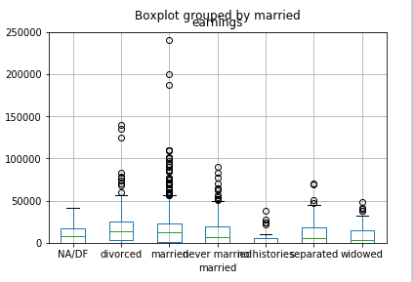

**Hypothesis**

**H0: families in the United States their**

**H1:**

**Visualization**